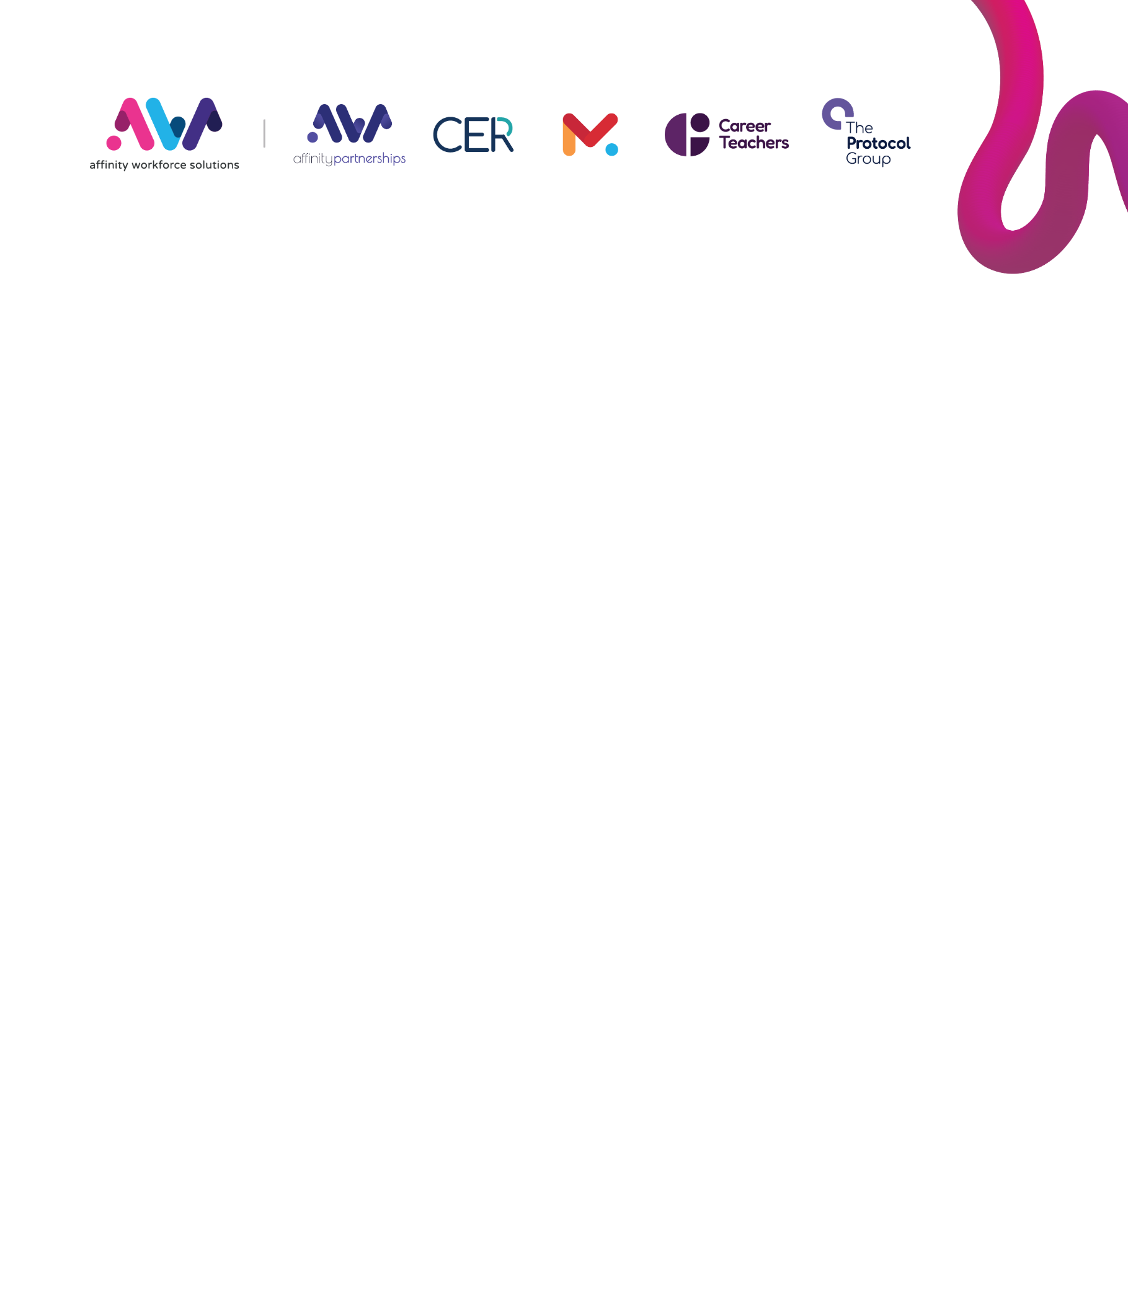

Modern Day Anti-Slavery Policy
Introduction

The Company, Affinity Workforce Solutions Ltd. and all associated companies and subsidiaries, are committed to promoting and maintaining the highest level of ethical standards in relation to all business activities. Its reputation for maintaining lawful business practices is of paramount importance and this Policy is designed to preserve these values and prevent against Modern Slavery, which encompasses slavery, servitude, human trafficking and forced labour.

Purpose & Scope
This statement is made under our legal and regulatory obligations pursuant to section 54(1) of the UK’s Modern Slavery Act 2015 (the Act) and sets out the steps we have and continue to take to ensure that modern slavery or human trafficking is not taking place within our business or supply chain.
The company are proud of the group wide conditions under which employees, temporary workers and contractors are engaged. Given the nature of our business, our Board and Senior Management teams each consider that there is minimal risk (approximating to no risk) that, either within the Group or across our limited supply chains which support our business activities, we are in any way involved in or even tangentially supportive of, or complicit in slavery and human trafficking.
The employment and procurement practices operated by the businesses within the Group ensure that the companies within our Group are rightly viewed as excellent and supportive employers.
To this extent, our Group companies operate as purchasers of goods and/or services, and therefore we expect a high level of ethical conduct from those businesses with which we conduct business.

Anti-Slavery Policy Statement:
The Company has a zero tolerance policy towards any form of slavery and human trafficking and is committed to acting ethically, fairly and with integrity and transparency in all business dealings and relationships and implementing effective systems and controls to safeguard against any form of slavery or human trafficking from taking place within our organisation or that of our supply chain.
This Anti-Slavery Policy Statement is the principal articulation of the Group’s policy on slavery and human trafficking and is intended to inform and influence all company operating procedures.

Group Structure
The company is incorporated in England, with its registered Head Office located in London. All sub-brands of the Group serve a purpose ancillary to the Group’s principal activities of supporting nurseries, schools, Multi-Academy Trusts, colleges & universities in providing high-quality recruitment and staffing services by supplying expert professionals across the education sector, and on both a temporary and permanent basis.
The companies forming part of Affinity Workforce as a Group and for which this policy relates, are provided at Annex A to this Policy.

Company Policies
The Company maintains a range of policies to support ethical and transparent business practices, including but not limited to:
- Modern Day Anti-Slavery Policy
- Recruitment & Screening Policy
- Compliance Policy
- Whistleblowing Policy
- Safeguarding Adults & Children Policies
- Anti-Bribery Policy
The Group companies also articulate a series of employee rights and benefits available to employees in the employee handbooks and individual contracts of employment for each member of staff.
Each of the subsidiary operating companies has an Executive Officer or Director who have reviewed and agreed to the terms of this statement. Each of these executives has reporting responsibilities to management and the various boards of companies within the Group. The Group uses the services of Cooper Parry, Sky View Argosy Road, East Midlands Airport, Castle Donington, Derby, DE74 2SA as the external auditor and receives regular update reports from both the external auditors and its own internal auditor and finance function. A combination of these procedures and functions operates to help identify, assess and monitor potential risk areas and mitigate the risk of slavery and human trafficking occurring in our business and supply chains.
In the articulation of this Anti-Slavery Policy Statement, we seek to ensure when entering into material contracts that all suppliers forming our supply chain comply with our stated Anti-Slavery Policy in particular when seeking tenders for services and when auditing our suppliers.
Supply Chains
The company operates a supplier policy, an approved supplier engagement process, and from which a limited preferred/approved supplier list is maintained. All suppliers are subject to due diligence processes prior to being approved as suitable for inclusion on our Preferred Supplier Register. These due diligence processes include, but are not limited to, online vetting checks to ensure each organisation has never been convicted of any offences which relate to or give rise to concerns regarding modern day slavery.
This anti-slavery policy forms part of our contract with all suppliers and they are required to confirm that no part of their business operations contradicts this policy. In addition and as part of our contract with suppliers, authorised signatory confirmation that:
- They have taken steps to eradicate modern slavery within their business;
- They hold their own suppliers to account over modern slavery;
- They pay all employees at least the national minimum wage/national living wage (as appropriate, or London Living Wage for London only) currently in operation;
- We may terminate the contract at any time should any instances of modern slavery come to light.

Due Diligence & Assessing Slavery/Human Trafficking
As part of our initiative and duty of care as an employer, we aim to directly identify actual, or the potential for, human trafficking and/or slavery, using the following and direct methods:
- Assessing the physical appearance of candidates or current employees/staff at interview and/or other arranged meetings/appointments; whilst maintaining an awareness of the signs of psychological abuse (i.e. malnourishment, unkemptness, those that appear withdrawn/fearful or who wear the same clothes daily);
- Record details of persons who attend the office accompanied by others, i.e. those who don’t or are unable to travel alone, appear under the influence of others, fail to interact or appear fearful, those reluctant to discuss current circumstances/arrangements/available working patterns, or who are unfamiliar with the local area/region;
- Record details of persons who do not have, or have difficulty in producing, their own personal identification and/or other documents/records, or have to seek these from other persons;
- Monitor registered addresses of personnel using e-systems to ensure employees/staff who have not declared themselves as family or marital/civil or other partners, are not residing at the same address unless a reasonable justification exists;
- Record details of persons who upon being offered temporary/permanent work positions firstly seek agreement from family/partners/other persons prior to acceptance, or similarly whose family/partners liaise with the company on behalf of the person;
- Operate a policy whereby all employees/staff must arrange and discuss their employment/work/assignments/patterns/availability etc. directly with the company themselves, and not through a third party, unless a suitable justification exists.
Training
Our policy and processes for the prevention of slavery and human trafficking will be communicated to all employees, temporary workers and contractors to ensure a high level of understanding of the risks of modern slavery and human trafficking, and will further form part of the company’s training and supporting materials.
Responsibility & Review
This policy is endorsed and regulated by the Group CEO and has full support of the Statutory and Managing Board of Directors, and Management team. The effectiveness of this policy and strategy shall be monitored on an annual basis or as and when changes to legislation are made to ensure fairness and suitability. The responsibility for ensuring compliance with this policy lies with the company’s Senior Management Team.

Policy Approval:

Name: | Alex Champion
Position: Group Chief Operating Officer
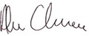
Signed:
Date approved: 08.09.2025
Comments on this Policy - If you would like to comment or complain about this policy, please contact the Policy Team by email ( lauren.griffiths@affinityworkforce.com ).

Annex A
Group Subsidiaries & Associated Companies
The Company, comprises the following subsidiaries and associated companies:
- Affinity Partnerships
- Career Teachers
- CER
- Monarch Education
- The Protocol Group

